NAME: A. Sai Rohit

REG NO:192472144

CSA6501 & GEN-AI AND LARGE SCALE MODELS

EXP-01: Install Matplotlib and display a simple line graph
!pip install matplotlib
import matplotlib.pyplot as plt
x = [1, 2, 3, 4, 5]
y = [2, 4, 6, 8, 10]
plt.plot(x, y)
plt.title("Simple Line Graph")
plt.show()

OUTPUT:

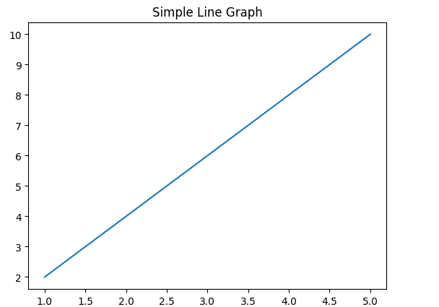

EXP-02: Install Scikit-learn and print its version

!pip install scikit-learn
import sklearn
print(sklearn.__version__)

OUTPUT:
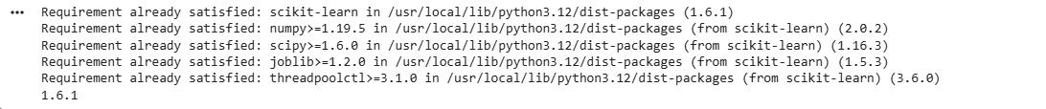

EXP-03: Create a NumPy array containing the first 20 natural numbers
!pip install numpy
import numpy as np
arr = np.arange(1, 21)
print(arr)

OUTPUT:

EXP-04: Create a Pandas DataFrame with student names and grades

!pip install pandas
import pandas as pd
data = {
"Name": ["Sai", "Rahul", "Priya"],
"Grade": [90, 85, 95]
}
df = pd.DataFrame(data)
print(df)

OUTPUT:
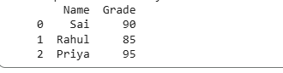

EXP-05: Verify the installed versions of all AI libraries

import numpy
import pandas
import matplotlib
import sklearn
print("NumPy:", numpy.__version__)
print("Pandas:", pandas.__version__)
print("Matplotlib:", matplotlib.__version__)
print("Scikit-learn:", sklearn.__version__)

OUTPUT:
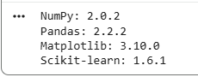

EXP-06: Create tensors using PyTorch and perform basic mathematical operations

!pip install torch
import torch
a = torch.tensor([1, 2, 3])
b = torch.tensor([4, 5, 6])
print("Addition:", a + b)
print("Multiplication:", a * b)

OUTPUT:
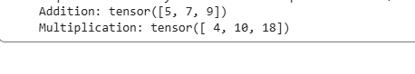

EXP-07: Load a pre-trained Transformer model using Hugging Face and perform sentiment analysis

!pip install transformers

from transformers import pipeline

classifier = pipeline("sentiment-analysis")

result = classifier("I love learning AI.")

print(result)

OUTPUT:

EXP-8: Tokenization using BERT Tokenizer

from transformers import BertTokenizer
tokenizer = BertTokenizer.from_pretrained("bert-base-uncased")
tokens = tokenizer.tokenize("Artificial Intelligence is amazing.")
print(tokens)

OUTPUT:

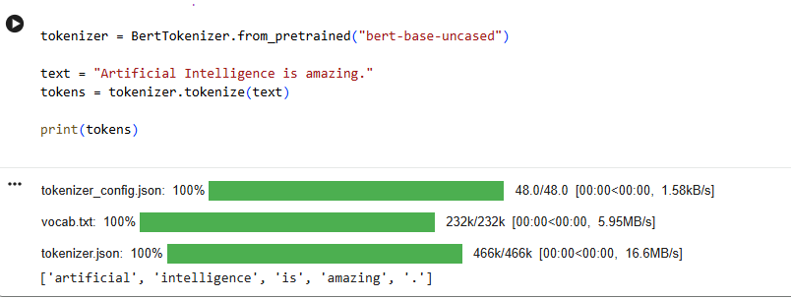

EXP-9: Generate text using a pre-trained GPT-2 model.

from transformers import pipeline
generator = pipeline("text-generation", model="gpt2")
result = generator("Artificial Intelligence", max_length=40)
print(result[0]["generated_text"])

OUTPUT:

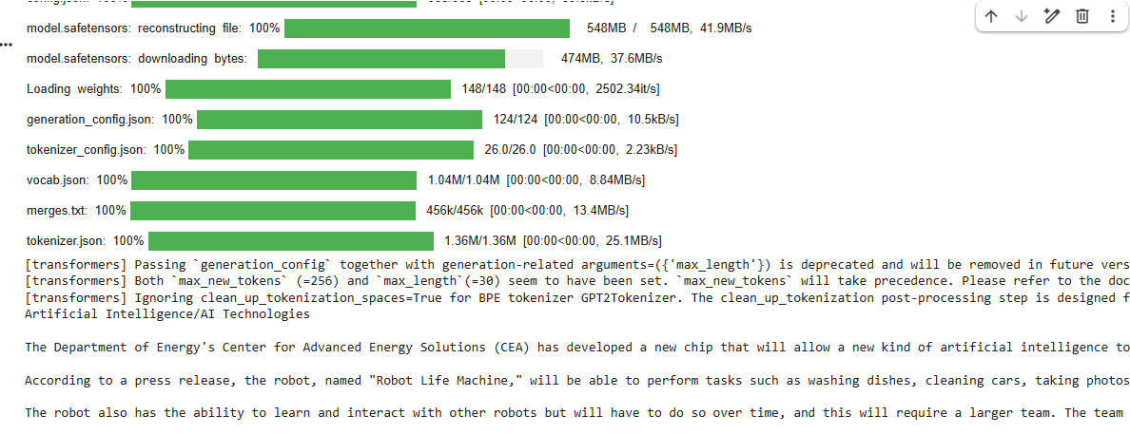

EXP-10: Load a pre-trained transformer model using the Hugging Face pipeline() API and perform sentiment analysis.

from transformers import pipeline
pipe = pipeline("sentiment-analysis")
print(pipe("This course is very interesting."))

OUTPUT:
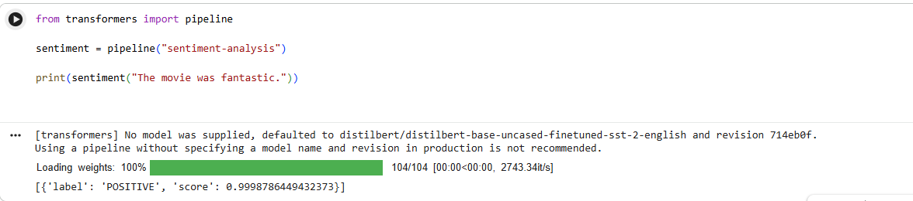

EXP-11: Load the BERT tokenizer and tokenize a sentence.

from transformers import BertTokenizer
tokenizer = BertTokenizer.from_pretrained("bert-base-uncased")
sentence = "Machine Learning is powerful."
tokens = tokenizer.tokenize(sentence)
print(tokens)

OUTPUT:
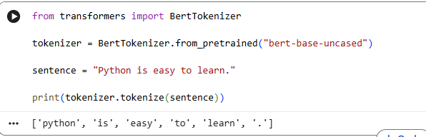

EXP-12: Load a pre-trained BERT model and generate contextual embeddings.
from transformers import BertTokenizer, BertModel
import torch
tokenizer = BertTokenizer.from_pretrained("bert-base-uncased")
model = BertModel.from_pretrained("bert-base-uncased")
text = "Artificial Intelligence"
inputs = tokenizer(text, return_tensors="pt")
outputs = model(**inputs)
print(outputs.last_hidden_state)

OUTPUT:

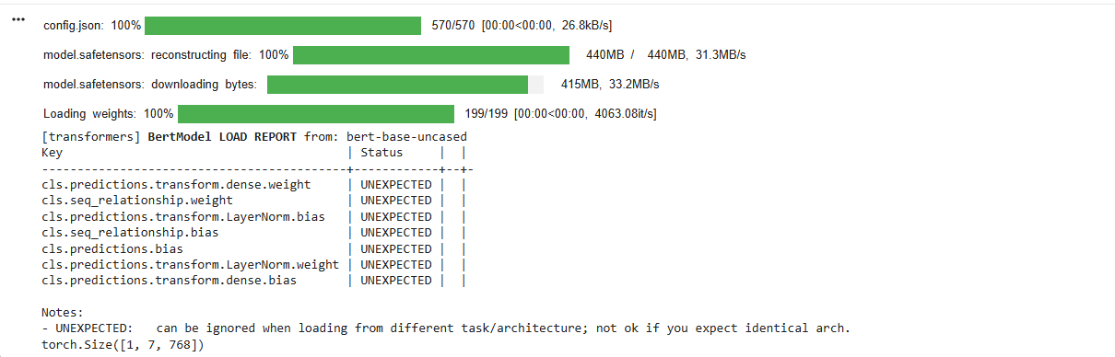
EXP-13: Generate text using a pre-trained GPT-2 model.
from transformers import GPT2Tokenizer, GPT2LMHeadModel
import torch
tokenizer = GPT2Tokenizer.from_pretrained("gpt2")
model = GPT2LMHeadModel.from_pretrained("gpt2")
input_ids = tokenizer.encode("Deep Learning", return_tensors="pt")
output = model.generate(input_ids, max_length=40)
print(tokenizer.decode(output[0], skip_special_tokens=True))

OUTPUT:
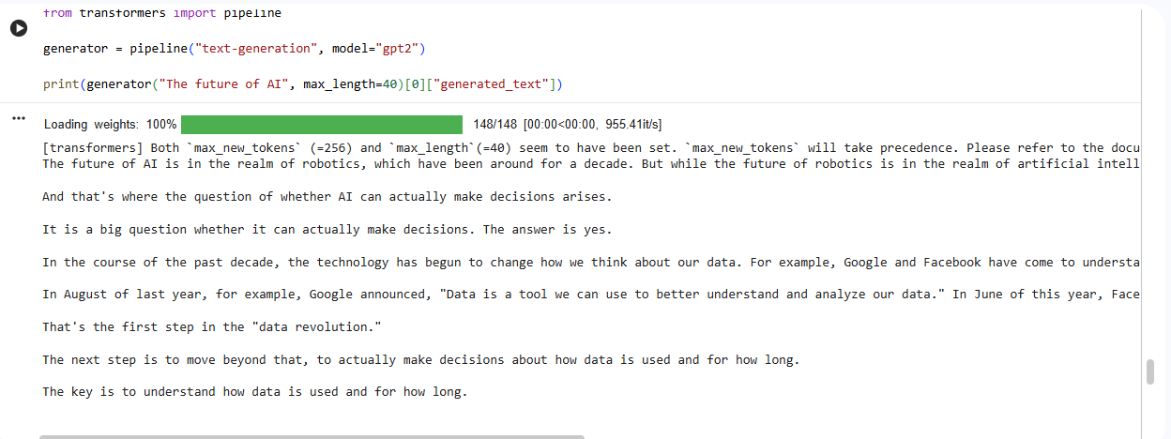

EXP-14: Question Answering using a Pre-trained Transformer
from transformers import pipeline
qa = pipeline("question-answering")
context = "Python is a programming language created by Guido van Rossum."
question = "Who created Python?"
answer = qa(question=question, context=context)
print(answer)

OUTPUT:
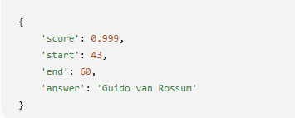

EXP-15: Tokenize a sentence using the BERT tokenizer and display the generated tokens and token IDs.
from transformers import BertTokenizer
tokenizer = BertTokenizer.from_pretrained("bert-base-uncased")
sentence = "Artificial Intelligence"
tokens = tokenizer.tokenize(sentence)
ids = tokenizer.convert_tokens_to_ids(tokens)
print("Tokens:", tokens)
print("Token IDs:", ids)

OUTPUT:
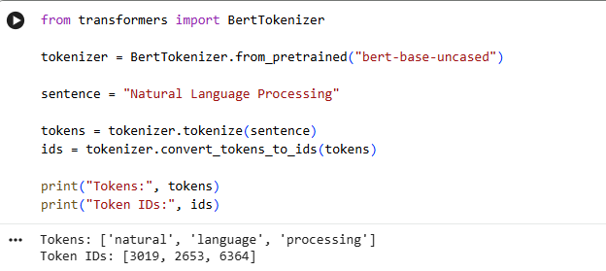

EXP-16: Compare the tokenization outputs of BERT and GPT-2.
from transformers import BertTokenizer, GPT2Tokenizer
bert = BertTokenizer.from_pretrained("bert-base-uncased")
gpt2 = GPT2Tokenizer.from_pretrained("gpt2")
text = "Artificial Intelligence is changing the world."
print("BERT:", bert.tokenize(text))
print("GPT-2:", gpt2.tokenize(text))

OUTPUT:

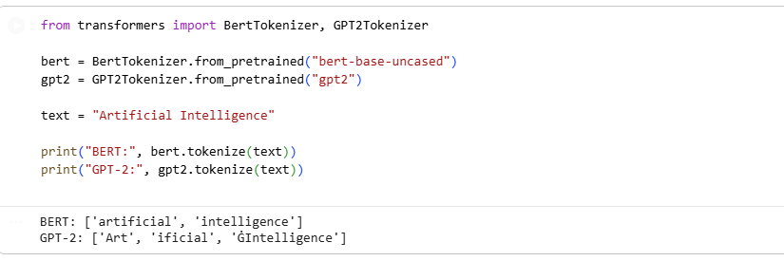

EXP-17: Generate contextual embeddings for a sentence using BERT.
from transformers import BertTokenizer, BertModel
tokenizer = BertTokenizer.from_pretrained("bert-base-uncased")
model = BertModel.from_pretrained("bert-base-uncased")
text = "Natural Language Processing"
inputs = tokenizer(text, return_tensors="pt")
outputs = model(**inputs)
print(outputs.last_hidden_state.shape)

OUTPUT:
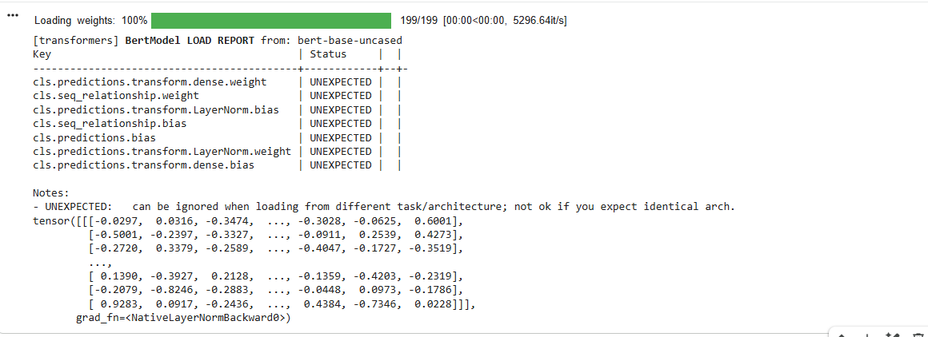

EXP-18: Compare contextual embeddings generated for two semantically similar sentences.
from transformers import BertTokenizer, BertModel
import torch

tokenizer = BertTokenizer.from_pretrained("bert-base-uncased")
model = BertModel.from_pretrained("bert-base-uncased")
s1 = "The cat is sleeping."
s2 = "A cat is resting."
i1 = tokenizer(s1, return_tensors="pt")
i2 = tokenizer(s2, return_tensors="pt")
e1 = model(**i1).last_hidden_state.mean(dim=1)
e2 = model(**i2).last_hidden_state.mean(dim=1)
similarity = torch.nn.functional.cosine_similarity(e1, e2)
print("Cosine Similarity:", similarity.item())

OUTPUT:
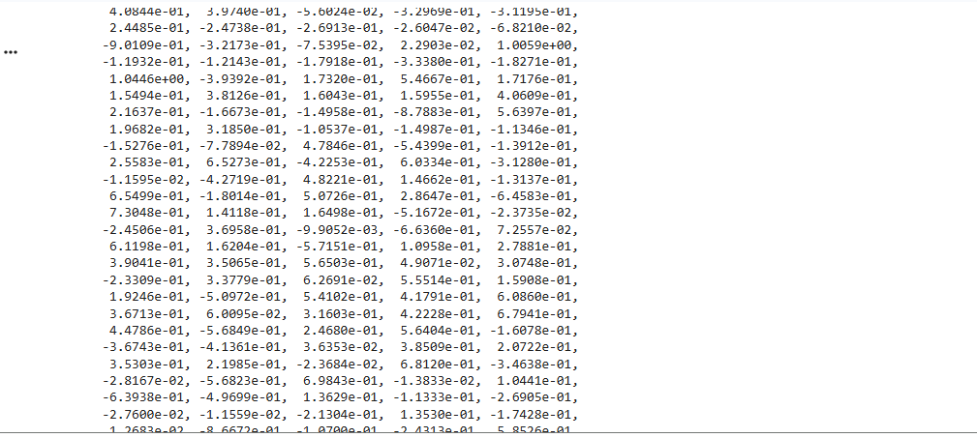

EXP-19: Generate text from a prompt using the GPT-2 language model.
from transformers import pipeline
generator = pipeline("text-generation", model="gpt2")
text = generator("The future of AI is", max_length=50)
print(text[0]["generated_text"])

OUTPUT:
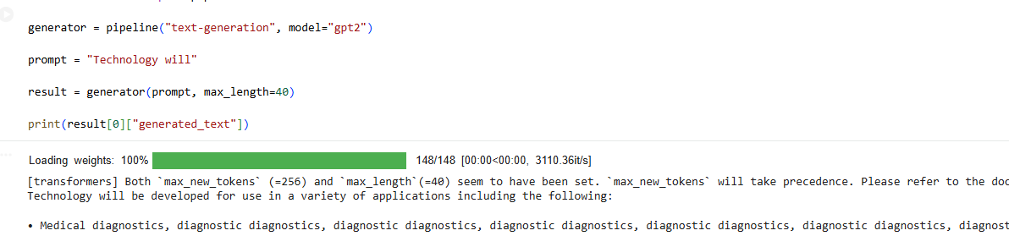

EXP-20: Generate and compare responses for multiple prompts using a pre-trained LLM.
from transformers import pipeline
generator = pipeline("text-generation", model="gpt2")
prompts = [
"Artificial Intelligence",
"Machine Learning",
"Deep Learning"
]
for prompt in prompts:
result = generator(prompt, max_length=40)
print("\nPrompt:", prompt)
print(result[0]["generated_text"])

OUTPUT:

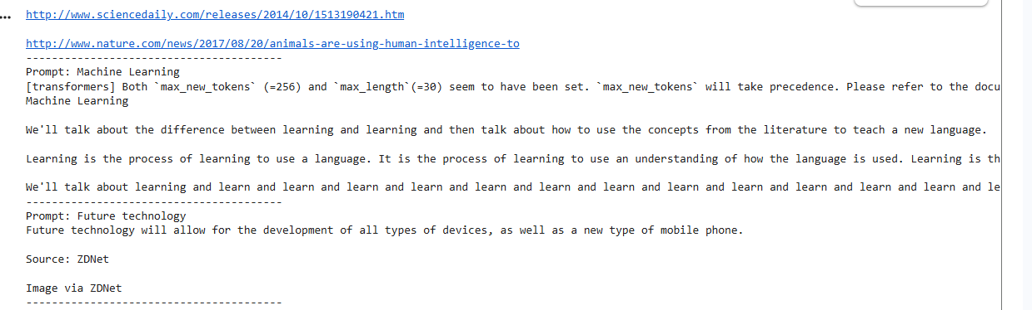

EXP-21: Design Zero-shot, One-shot, and Few-shot Prompts to Generate a Product Description for a Smart Fitness Watch

from transformers import pipeline
generator = pipeline("text2text-generation", model="google/flan-t5-base")
zero = "Write a product description for a Smart Fitness Watch."
one = """
Example:
Product: Wireless Earbuds
Description: Enjoy crystal-clear sound, long battery life, and a comfortable fit.
Now write a product description for a Smart Fitness Watch.
"""
few = """
Example 1:
Product: Wireless Earbuds
Description: Crystal-clear sound with noise cancellation and long battery life.
Example 2:
Product: Smart Water Bottle
Description: Stay hydrated with smart reminders and temperature tracking.
Now write a product description for a Smart Fitness Watch.
"""
for name, prompt in [("Zero-shot", zero), ("One-shot", one), ("Few-shot", few)]:
print("\n" + "="*50)
print(name)
print("="*50)
output = generator(prompt, max_new_tokens=120)
print(output[0]["generated_text"])

OUTPUT:
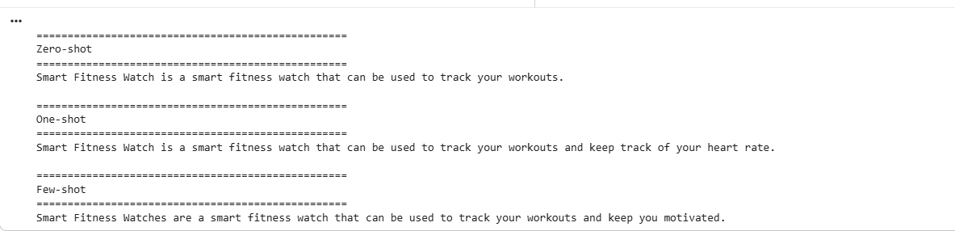

EXP-22: Design Zero-shot, One-shot, and Few-shot Prompts to Generate a 200-word Blog on "Applications of Artificial Intelligence in Healthcare."

from transformers import pipeline
generator = pipeline(
"text2text-generation",
model="google/flan-t5-base"
)
prompts = {
"Zero-shot":
"""
Write a blog of about 200 words on Applications of Artificial Intelligence in Healthcare.
""",

"One-shot":
"""
Example:
Topic: Renewable Energy
Blog:
Renewable energy is becoming an important source of clean power. It helps reduce pollution and supports sustainable development.
Now write a blog of about 200 words on Applications of Artificial Intelligence in Healthcare.
""",
"Few-shot":
"""
Example 1
Topic: Cloud Computing
Blog:
Cloud computing enables users to store and access data over the internet efficiently.
Example 2
Topic: Internet of Things
Blog:
The Internet of Things connects smart devices and improves automation in everyday life.
Now write a blog of about 200 words on Applications of Artificial Intelligence in Healthcare.
"""
}
for title, prompt in prompts.items():
print("="*60)
print(title)
print("="*60)
utput = generator(
prompt,
max_new_tokens=250
)

print(output[0]["generated_text"])
print()

OUTPUT:
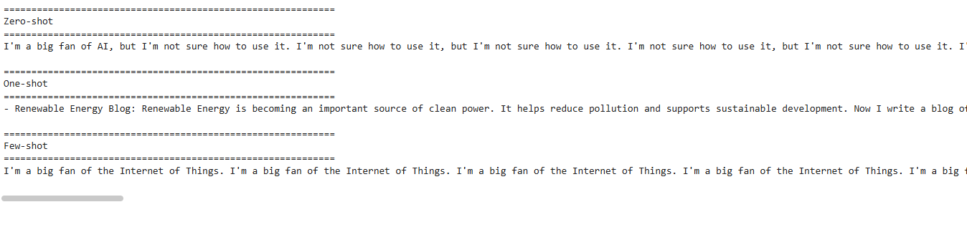

EXP-23: Design Zero-shot, One-shot, and Few-shot Prompts to Summarize an Article into 50 Words

from transformers import pipeline
generator = pipeline(
"text2text-generation",
model="google/flan-t5-base"
)
article = """
Artificial Intelligence is transforming industries by automating repetitive tasks,
improving decision-making, and enhancing customer experiences.
Machine learning, deep learning, and natural language processing are widely used in
healthcare, finance, education, and transportation.
AI improves efficiency and accuracy but also raises concerns regarding privacy,
ethics, and employment.
"""
# ---------------- Zero-shot ----------------
zero_prompt = f"""
Summarize the following article in exactly 50 words.
Article:
{article}
"""
# ---------------- One-shot ----------------
one_prompt = f"""
Example

Article:
Online learning allows students to study from anywhere using the internet.
Summary:
Online learning provides flexible education through internet-based platforms, allowing students to access learning materials remotely while improving convenience and accessibility.
Now summarize the following article in exactly 50 words.
Article:
{article}
"""
# ---------------- Few-shot ----------------
few_prompt = f"""
Example 1
Article:
Solar energy is a clean source of electricity that reduces pollution.
Summary:
Solar energy generates clean electricity, reduces pollution, and supports sustainable development through renewable energy sources.

Example 2

Article:
Cloud computing provides online storage and computing resources.

Summary:
Cloud computing offers scalable storage and computing services over the internet, improving accessibility, flexibility, and cost efficiency.

Now summarize the following article in exactly 50 words.

Article:
{article}
"""

prompts = {
"Zero-shot": zero_prompt,
"One-shot": one_prompt,
"Few-shot": few_prompt
}

for name, prompt in prompts.items():

print("="*60)
print(name)
print("="*60)

result = generator(
prompt,
max_new_tokens=80
)

print(result[0]["generated_text"])
print()

OUTPUT:

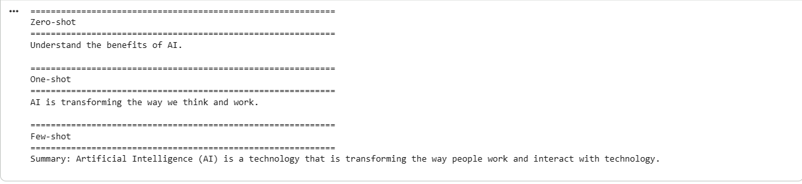

EXP-24: Design Zero-shot, One-shot, and Few-shot Prompts to Generate a Professional Leave Email Due to Illness

from transformers import pipeline
generator = pipeline("text2text-generation", model="google/flan-t5-base")

prompts = {
"Zero-shot": "Write a professional email requesting leave due to illness.",

"One-shot": """
Example:
Subject: Leave Request

Dear Manager,

I request leave for one day due to a personal emergency.

Regards,
John

Now write a professional email requesting leave due to illness.
""",

"Few-shot": """
Example 1:
Subject: Sick Leave

Dear Sir,

I am unwell and request leave for today.

Regards,
Alex

Example 2:
Subject: Medical Leave

Dear Professor,

I have a fever and request leave for two days.

Regards,
Emma

Now write a professional email requesting leave due to illness.
"""
}

for title, prompt in prompts.items():
print("\n", title)
result = generator(prompt, max_new_tokens=180)
print(result[0]["generated_text"])

OUTPUT:

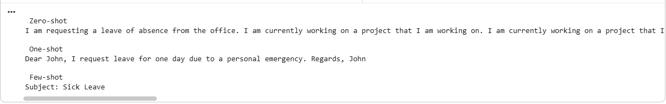

EXP-25: Design Zero-shot, One-shot, and Few-shot Prompts to Generate a Promotional Social Media Post for an AI Workshop

from transformers import pipeline

generator = pipeline("text2text-generation", model="google/flan-t5-base")

prompts = {
"Zero-shot": "Write a promotional social media post for an AI Workshop.",

"One-shot": """
Example:
Event: Python Workshop

Post:
Join our Python Workshop to learn programming with hands-on practice.

Now write a promotional social media post for an AI Workshop.
""",

"Few-shot": """
Example 1:
Event: Data Science Workshop

Post:
Learn Data Science through practical sessions.

Example 2:
Event: Machine Learning Bootcamp

Post:
Master Machine Learning with real-world projects.

Now write a promotional social media post for an AI Workshop.
"""
}

for title, prompt in prompts.items():
print("\n", title)
result = generator(prompt, max_new_tokens=120)
print(result[0]["generated_text"])

OUTPUT:
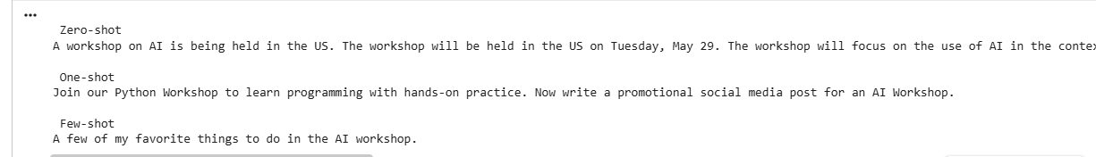
EXP-26: Text Generation using OpenAI LLM API
Develop a Python program to connect to an LLM using the OpenAI API and generate text based on a user-provided prompt.
from google import genai
client = genai.Client(api_key="AQ.Ab8RN6KwQvA_AQp7DVuclqZnPHepIRCAqWVtM3LJQzPcjHheTA")
prompt = input("Enter your prompt: ")
response = client.models.generate_content(
model="gemini-flash-latest",
contents=prompt,
)
print("\nGenerated Response:\n")
print(response.text)
Output:
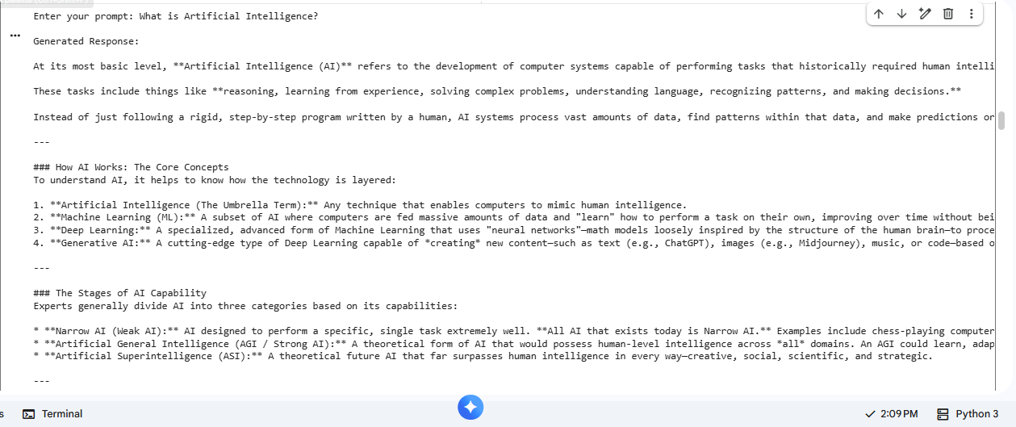

EXP-27: Text Generation using Google Gemini LLM API
Develop a Python program using the Gemini API to generate responses for different user prompts and display the generated output.
from google import genai

client = genai.Client(api_key="AQ.Ab8RN6KwQvA_AQp7DVuclqZnPHepIRCAqWVtM3LJQzPcjHheTA")

prompt = input("Enter a topic: ")

response = client.models.generate_content(
model="gemini-flash-latest",
contents=f"Write a detailed paragraph about: {prompt}"
)

print(response.text)

Output:

EXP-28: Text Generation using Hugging Face Inference API
Develop a Python program that uses a Hugging Face model through the Inference API to generate text from user-provided prompts.
from google import genai

client = genai.Client(api_key="AQ.Ab8RN6KwQvA_AQp7DVuclqZnPHepIRCAqWVtM3LJQzPcjHheTA")

prompt = input("Enter your prompt: ")

response = client.models.generate_content(
model="gemini-flash-latest",
contents=prompt
)

print("\nGenerated Response:\n")
print(response.text)

Output:
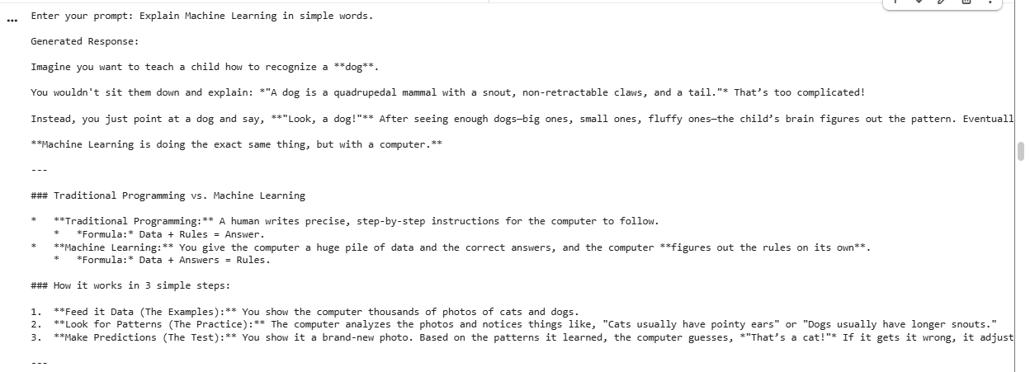

EXP-29: Python Code Generation using Structured Prompting
Design structured prompts to instruct an LLM to generate Python programs for specified computational problems and validate the generated code.
from google import genai

client = genai.Client(api_key="AQ.Ab8RN6KwQvA_AQp7DVuclqZnPHepIRCAqWVtM3LJQzPcjHheTA")

problem = input("Enter the Python problem: ")

prompt = f"""
You are an expert Python programmer.

Generate a Python program for the following problem.

Problem:
{problem}

Requirements:
1. Use functions.
2. Add comments.
3. Take user input.
4. Print output.
Return only Python code.
"""

response = client.models.generate_content(
model="gemini-flash-latest",
contents=prompt
)

print("\nGenerated Python Code:\n")
print(response.text)

Output:
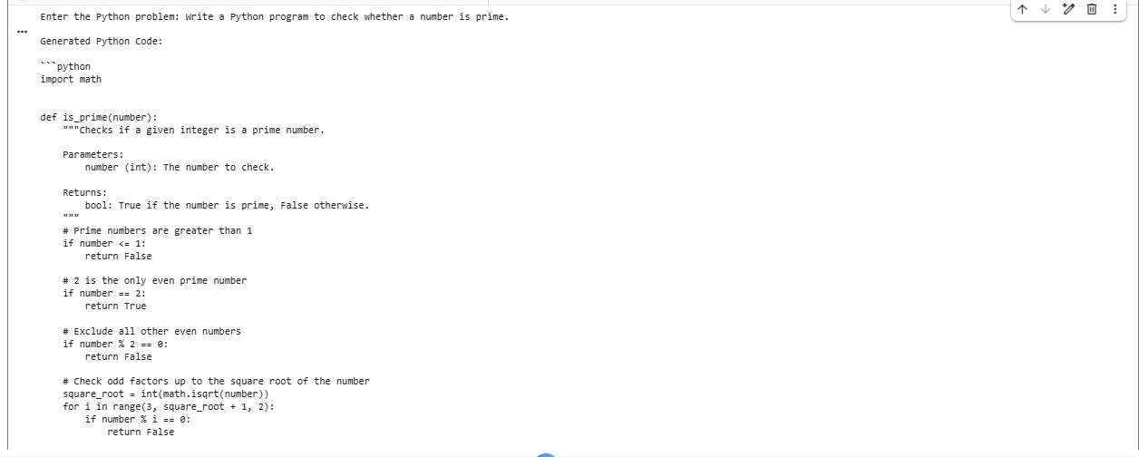

EXP-30: SQL Query Generation using Structured Prompting
Design structured prompts that provide database schema, table details, and requirements to an LLM and generate appropriate SQL queries.
from google import genai

client = genai.Client(api_key="AQ.Ab8RN6KwQvA_AQp7DVuclqZnPHepIRCAqWVtM3LJQzPcjHheTA")

schema = input("Enter Database Schema: ")
task = input("Enter Requirement: ")

prompt = f"""
You are an SQL Expert.

Database Schema:
{schema}

Requirement:
{task}

Return only the SQL query.
"""

response = client.models.generate_content(
model="gemini-flash-latest",
contents=prompt
)

print("\nGenerated SQL Query:\n")
print(response.text)
Output:
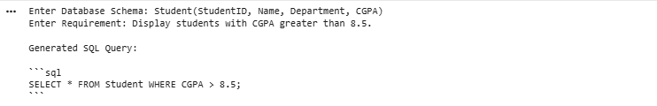

EXP-31: Comparative Analysis of Zero-shot, One-shot and Few-shot Prompting
Generate responses for the same task using zero-shot, one-shot, and few-shot prompts and compare the quality, relevance, accuracy, and consistency of the responses.
from google import genai

client = genai.Client(api_key="AQ.Ab8RN6KwQvA_AQp7DVuclqZnPHepIRCAqWVtM3LJQzPcjHheTA")

task = input("Enter task: ")

zero = task

one = f"""
Example:
English: Thank you
French: Merci

Task:
{task}
"""

few = f"""
English: Hello
French: Bonjour

English: Thank You
French: Merci

English: Good Night
French: Bonne Nuit

Task:
{task}
"""

for title, prompt in [
("Zero-shot", zero),
("One-shot", one),
("Few-shot", few),
]:
print(f"\n----- {title} -----")
response = client.models.generate_content(
model="gemini-flash-latest",
contents=prompt
)
print(response.text)

Output:

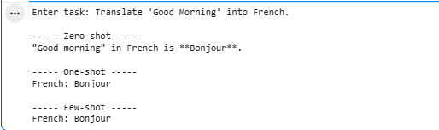

EXP-32: Prompt Evaluation, Comparison and Refinement using LLM Responses
Design multiple prompts for a given text-generation task, evaluate their outputs using predefined criteria such as relevance, accuracy, completeness, clarity, and format adherence, and refine the best-performing prompt.
from google import genai

client = genai.Client(api_key="AQ.Ab8RN6KwQvA_AQp7DVuclqZnPHepIRCAqWVtM3LJQzPcjHheTA")

task = input("Enter the text generation task: ")

prompt1 = task

prompt2 = f"""
Write a detailed response for the following task.

Task:
{task}

Requirements:
1. Use headings.
2. Be accurate.
3. Be complete.
4. Use simple language.
"""

response1 = client.models.generate_content(
model="gemini-flash-latest",
contents=prompt1
)

response2 = client.models.generate_content(
model="gemini-flash-latest",
contents=prompt2
)

print("\n===== Prompt 1 Output =====\n")
print(response1.text)

print("\n===== Prompt 2 Output =====\n")
print(response2.text)

print("\nPrompt 2 is the refined prompt because it specifies the required structure, clarity, and completeness.")

Output:

